HERTFORD COLLEGE
OXFORD

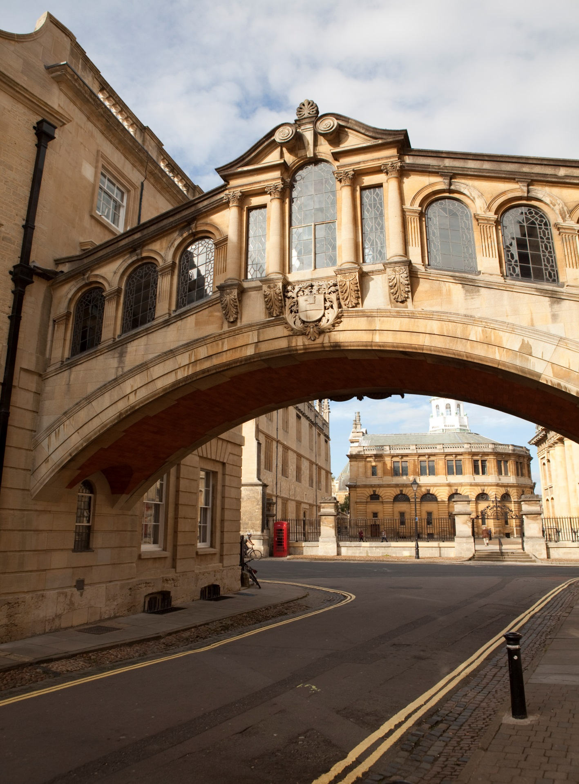

Jilin University

at

Hertford College, Oxford

Contemporary Britain

Two Week Programme

SUMMER 2017

SUMMER 2017

A very warm welcome to Hertford College and to Oxford!

Hertford College was founded in 1282 – it is one of the oldest of Oxford University’s 38 colleges. Located in the centre of historic Oxford, our beautiful college boasts the Bridge of Sighs, which is one of the most famous sights of the city. This is an ideal setting for students wishing to improve their language skills and knowledge of Britain and British culture.

Welcome to
Oxford!

MEALS

Meals:

- On class days, you are offered breakfast, lunch and dinner.

- On trip days you are offered breakfast, a packed lunch and dinner.

- Weekend: Saturday you are offered breakfast. Sunday you are offered breakfast and dinner.

- On free-weekdays (Monday-Friday) you are offered breakfast, lunch and dinner.

The following pages outline your academic programme
ARRIVAL DAY  Day 1  Saturday  12th August | - Arrive at Heathrow Airport, London.  - Hertford College Residential Advisors (RAs) will meet you.  - Travel to Oxford by private coach. You will stay in Oxford University accommodation.  - On arrival: welcome meal and information
Day 2  Sunday  13th August | Study Tour: London  Enjoy a trip to the capital city and experience the magical sights and sounds of London in the comfort and safety of your private coach. You will visit two of London’s most famous attractions – the British Museum and the National Gallery.
WEEK ONE | 9.00 –10.30am |  |  | 11.00 – 12.30pm |  | 2.00-4.00pm |  | Evening
Day 3  Monday  14th August | Introduction to Oxford: the City and the University  An in-depth examination of Oxford’s history. We look at the complex relationship between the University and the thriving civic community that has developed around it. The lecture is followed by a Q and A session on the university’s application process and student life with Oxford University students. |  |  |  | L  U  N  C  H | Welcome Tea at 3.00pm  Sample a delicious and traditional cream tea in the splendid surroundings of Hertford College’s historic dining room.  Please wear smart clothes. | D  I  N  N  E  R | Orientation  - Accommodation  - Facilities  - Connecting your computers to the internet
Day 4  Tuesday  15th August | Lecture  The United Kingdom  Deepen your knowledge of how the four constituent countries fit together to form the UK. We also consider the implications of the Brexit vote. |  | B  R  E  A  K | Introduction to the British Political System  Learn how the country is governed and administrated on both the national and local levels. | L  U  N  C  H | International Job Seeking Skills 1  - How to write an effective letter of application or personal statement  - CVs  - Researching a company | D  I  N  N  E  R | Cultural activities with RAs  Suggestion  College quiz night
Day 5  Wednesday  16th August | Advanced Social English  - Colloquial English  Successful interaction: how to be ‘spontaneous’ in your conversation  - ‘Language Register’: how to communicate in a polite and appropriate manner | B  R  E  A  K |  | Oxford Architecture  Discover the form and function of Oxford’s most famous and beautiful buildings.  Oxford Famous Faces  An overview of the achievements of some of Oxford’s most noted alumni | L  U  N  C  H | Out and About Tour of Discovery  A self-guided exploration of the hidden corners of Oxford | D  I  N  N  E  R | Cultural activities with RAs  Suggestion  Visit a popular Oxford ice cream café
Day 6  Thursday  17th August | Lecture  Contemporary Youth Culture  Britain has been at the forefront of youth culture since the 1950s. Explore the world of fashion and music enjoyed by young people. | B  R  E  A  K |  | The Language of Debate  Learn how to present your opinions clearly and take part in a mini-debate in groups.  - Expressing your opinion and commenting  - Turn-taking  - Agreeing/Disagreeing | L  U  N  C  H | Lecture  Art in Britain  Study the artists who have shaped and challenged our concept of art in Britain today. You will be looking at both gallery and non-gallery art. | D  I  N  N  E  R | Cultural activities with RAs  Suggestion  Stroll along the River Thames
Day 7  Friday  18th August | Free time
Day 8  Saturday  19th August | Weekend
Day 9  Sunday  20th August | Weekend
WEEK TWO | 9.00 – 10.30am |  |  | 11.00 – 12.30pm |  | 2.00 – 4.00pm |  | Evening
Day 10  Monday  21st August | Lecture  Electronic Governance or E-Governance in Britain  Learn about the application of information and communication technology (ICT) See how it delivers government services, facilitates exchange of information, transactions and services between government, citizens and businesses | B  R  E  A  K |  | International Job Seeking Skills 2  - How to prepare for a job interview  - Interview role-play | L  U  N  C  H | Team Building and Leadership  - Learn how to create and manage a successful, motivated team.  - Experiment with different leadership and management theories in this fun and thought-provoking group activity | D  I  N  N  E  R | Cultural activities with RAs  Suggestion  Film night
Day 11  Tuesday  22nd August | Lecture  The Press and Media in the UK  The language of journalism, an exploration of daily publications and their journalistic influence on society | B  R  E  A  K |  | Introduction to Local Government  Discover how this complex system works in the UK, from local councils to social services and public amenities, such as libraries and community centres. | L  U  N  C  H | Study Tour  An opportunity to see local government in action by visiting a local public library in a charming village outside Oxford | D  I  N  N  E  R | Cultural activities with RAs  Suggestion  Visit a historic Oxford pub
Day 12  Wednesday  23rd August | Study of a Literary Icon  Shakespeare—his life and works  Discover more about Shakespeare’s plays and his influence on the English language of today. | B  R  E  A  K |  | Language Focus  - Strategies for effective listening  - Listening activities: learn to recognise and use idiomatic expressions.  - Listening for gist | L  U  N  C  H | Presentation Workshop 2  - Advanced presentation techniques and language  - Body language and communicating with your audience | D  I  N  N  E  R | Cultural activities with RAs  Suggestion  Watch a Shakespeare play in an Oxford College garden
Day 13  Thursday  24th August | End of Course Presentations  Students deliver presentations in small groups before an audience. | B  R  E  A  K |  | End of Course Presentations (continued) | L  U  N  C  H | Feedback on Presentations and End of Course Assessment | D  I  N  N  E  R | GALA DINNER  Celebrate your success at a memorable candle-lit dinner in one of Hertford College’s historic dining rooms, where you will be presented with a certificate at the end-of-course ceremony.
Day 14  Friday  25th August | Free time
Day 15  Saturday  26th August | Weekend
Day 16  Sunday  27th August | Departure Day  You will be accompanied by the RAs in a private coach to the airport.

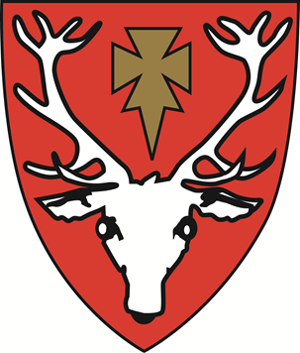
THE INTERNATIONAL PROGRAMMES DEPARTMENT

HERTFORD COLLEGE, OXFORD
The International Programmes Department,
Hertford College,
Catte Street,
OX1 3BW

Tel: 01865 279 356

